**Indian Demographics: Effecting Indian Economics**

Nalini S. Jagtap1, Hitesh Choudhary2, Sagar Rajkumar Gupta3, Suprabhat Shaurya4,Yash Tiwari5, Rohit Saktel6

**Abstract**. India's demographic panorama is present process a vast transformation. This studies paper investigates the multifaceted relationship between these demographic changes, consisting of declining fertility costs, a growing operating-age population, and growing urbanization, and their impact on India's Gross Domestic Product (GDP). The have a look at employs a combined-strategies approach, utilizing both quantitative statistics evaluation of census data and financial indicators along qualitative interviews with policymakers, industry leaders, and lecturers. The analysis famous a potential for a "demographic dividend," where a huge operating-age population can gasoline monetary growth. However, the research also identifies challenges related to this transition, inclusive of the want for skilling the workforce, dealing with inner migration, and ensuring equitable distribution of the economic benefits. By delving deeper into these findings, the paper discusses the outcomes for India's financial destiny, highlighting policy recommendations to maximize the nice results of demographic change.

**Keywords:** Demographics Changes, Urbanization and Migration, Gross Domestic Product

# Introduction

In recent years, India has witnessed profound shifts in its demographic landscape, propelled by urbanization, migration, and changing population dynamics. These demographic changes hold significant implications for the nation's economic trajectory, influencing various facets of its development. This research endeavors to delve into the intricate relationship between demographic transformations and the Indian economy, with a particular focus on understanding the underlying mechanisms and discerning their effects. The objectives of this study are multifaceted. Firstly, we aim to scrutinize the patterns and trends of demographic changes occurring within India, encompassing aspects such as population growth, urbanization rates, and migration patterns. By analyzing demographic data over time, we seek to uncover the nuanced dynamics shaping India's population landscape. Secondly, this research aims to elucidate the ramifications of these demographic shifts on the Indian economy. We will explore how changes in population composition, urbanization trends, and migration patterns intersect with economic variables, such as Gross Domestic Product (GDP) growth, labor market dynamics, and consumption patterns [16]. By assessing the impact of demographic transitions on key economic indicators, we aspire to gain insights into the mechanisms through which demographic changes influence India's economic performance [11].

Furthermore, this study endeavors to identify policy implications arising from the nexus between demographics and economics. By examining the implications of demographic changes on various sectors of the economy, including labor markets, healthcare, and infrastructure development, we aim to provide recommendations for policy interventions that can harness the opportunities and mitigate the challenges posed by demographic transformations [11]. In sum, this research seeks to contribute to the understanding of how demographic changes are reshaping the Indian economic landscape. By elucidating the interplay between demographics and economics, we aspire to provide valuable insights for policymakers, researchers, and stakeholders grappling with the implications of India's evolving population dynamics [12]. Through rigorous analysis and empirical investigation, we endeavour to shed light on the complex relationship between demographics and economics, paving the way for informed decision-making and sustainable development strategies in the Indian context. In sum, this

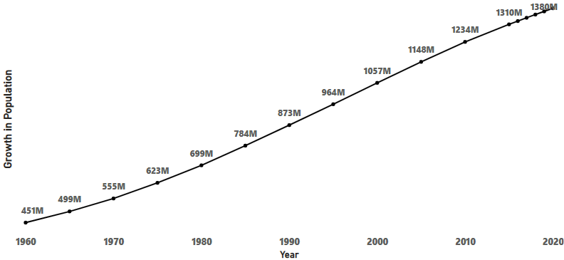

**Fig 1. Population Growth in India by Year**

research seeks to contribute to the understanding of how demographic changes are reshaping the Indian economic landscape. By elucidating the interplay between demographics and economics, we aspire to provide valuable insights for policymakers, researchers, and stakeholders grappling with the implications of India's evolving population dynamics. Through rigorous analysis and empirical investigation [9,10], we endeavor to shed light on the complex relationship between demographics and economics, paving the way for informed decision making and sustainable development strategies in the Indian context.

The research hopes to provide a thorough grasp of the complex nature of population shifts and their effects on the varied fabric of Indian life through this investigation [1,2,6]. Fig.1. Population Growth in India with its depiction of the demographic changes in India, Fig. 1, Population growth by year, offers an engaging overview of the country’s changing dynamics [8,17]. The story of population increase is summarized by the ascending curve, which shows the significant changes in birth rates, death rates, and average life expectancy. Every data point on Fig. 1 depicts a chapter in the demographic evolution of India, not merely a number value. The country’s demographic transitions, from high birth and death rates to an era of declining mortality and finally stabilized birth rates, are reflected in the continuous ascent.

The demographic landscape is further complicated by both internal and foreign migration. Internal migration has the power to change regional economies because it is motivated by things like job opportunities and quality of life. The skilled labor migration from India affects individual households as well as the national economy at the same time as it promotes knowledge transfer and remittances. But it also calls into question brain drain and the necessity of laws that strike a balance between the advantages of emigration and the need to keep qualified workers in the country. The impact of demographic shifts on the economy is measured by looking at GDP, which is a crucial measure of a country’s economic health. The study examines the complex links that exist between changes in the population and GDP growth [5], taking into account variables including consumption trends, labour force participation, and the contribution of various age groups to economic output. It explores solutions to these issues as well as the possible problems brought on by an aging population, such as rising healthcare costs and a declining labor force [2].

# Overview

A crucial thread that runs through the complex fabric of India’s past, present, and future is the area of population shifts in the country’s wide socioeconomic environment. When this dynamic realm is thoroughly examined via the prisms of migration, urbanization [1,3], and GDP, a story of transformation is revealed that goes beyond simple statistical data. When we explore this complex area, it becomes clear that the story of India’s demographic shifts is not limited to population growth but rather includes a wide range of cultural, social, and economic factors [7]. The demographic dividend, a phenomenon influenced by the changing age composition of the population, is at the centre of this investigation. India, is witnessing a dramatic demographic transformation, typified by dropping death rates, growing life expectancy, and shifting fertility trends. The demographic dividend that follows promises a growing labor force that could drive economic expansion. This potential is subject, though, to deliberate policies that take use of the demographic advantage by creating job opportunities, skill development programs, and inclusive economic efforts. One notable aspect of India’s demographic transformation is urbanization. In addition to changing the population’s spatial distribution, the constant migration of people from rural to urban areas has led to the emergence of urban centers as hubs for trade and cross-cultural interaction. A visual narrative is provided by Fig. 1, which shows the total population by year and shows an increase trajectory that corresponds with the pattern of urbanization [6, 7, 11].

Urban environments, with their vibrancy and diversity, offer economic development both prospects and difficulties. The graphic in Figure 2, which shows the overall number of people living in cities and the patterns in urbanization over time, tells the story of how India’s terrain has changed over time. The graph’s lines represent the dynamic process of urbanization as they move over time, providing information on the ebb and flow of people moving from rural to urban areas [7]. In addition to numerical statistics, the climbing curve depicts the forces of industrialization, economic growth, and shifting lifestyles that push people toward urban areas. It illustrates the increasing attraction of cities as centres of innovation, opportunity, and cross-cultural interaction.

An overview of the country’s urbanization trajectory can be obtained by examining

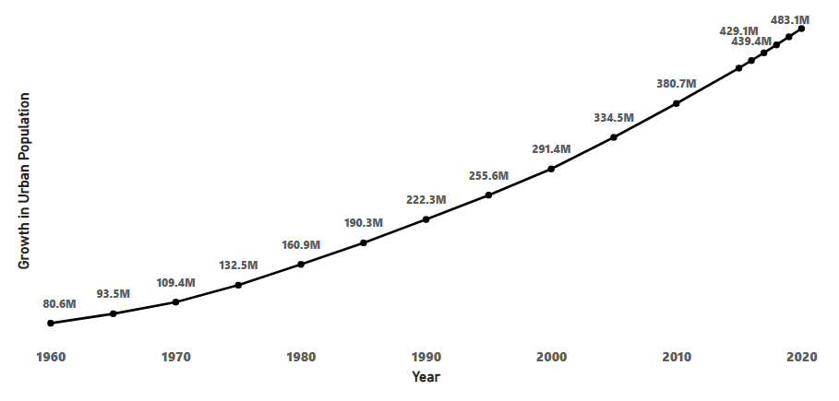

**Fig 2. Urban Population Growth by Year**

the annual variations in urbanization rates [2, 5]. The urbanization story is shaped by the intersection of multiple elements, including infrastructural development, societal goals, and economic policies, as represented by the graph’s peaks and valleys. The straightforward narrative of Fig 2. depicts a demographic shift, reflecting the dynamic nature of a country. It turns into a visual tool that provides insightful information about the rate and trends of urbanization to researchers, politicians, and urban planners.

The graph transforms into a compass as metropolitan regions grow, directing efforts to handle the difficulties and seize the benefits that come with this transformation. The generated graph, in its essence, is not just a collection of data points but a dynamic depiction of India’s urbanization story that invites us to interpret the story written in its curves and lines [3]. Millions of dreams are painted onto the metropolitan landscape, but it also necessitates careful planning to deal with housing, infrastructure, and resource management concerns. The story of demographic shifts is further enhanced by migration, both domestic and foreign [7]. Internal migration changes regional economies and adds to the urbanization phenomena since it is motivated by things like quality of life and work opportunities.

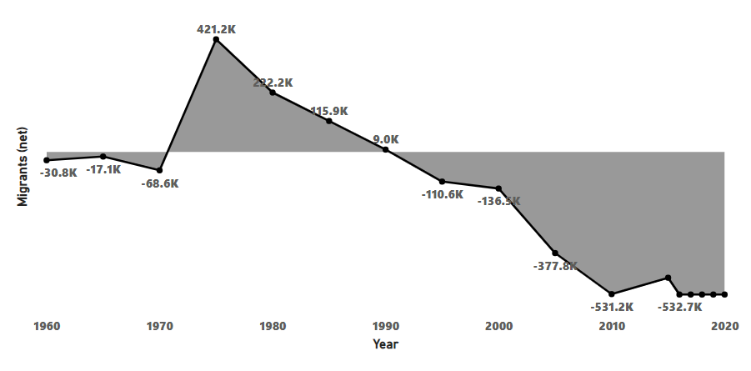**Fig 3. Migrants(net) by year**

A graphic depiction of the population shifts brought about by migration is shown in Fig. 3, which highlights how migration affects demographic trends. The movement of skilled labour from India around the world at the same time facilitates knowledge transfer and remittances, demonstrating the interdependence of the local and global aspects of population shifts [1,14]. With its markers representing different eras, the graph offers a visual record of how migratory patterns affect population dynamics. Still, this demographic story goes beyond numbers and statistical patterns. It explores the changes in sociocultural dynamics brought about by changes in the population mix. One important subplot is the rethinking of traditional gender roles by women as a result of their increased access to education and economic possibilities. Fig. 1, while depicting the increase in population [5].

The economic component, which is central to our investigation, is closely linked to changes in the population as seen through the prism of GDP. We can associate population dynamics with economic trends by using the year-by-year total population graph as a visual anchor. It draws attention to times of demographic dividend, in which an increase in the working-age population coincides with favourable business conditions, as well as any drawbacks associated with an aging population [16]. In order to understand the intricate interactions between variables including consumption habits, labour force participation, and the contribution of various age cohorts to economic productivity [2], the research article critically analyses the relationship between changes in the population and GDP growth. It emphasizes how crucial policy coherence is to fully utilizing the demographic dividend. The graph serves as a visual guide, showing us the highs and lows of population growth and providing information on the effects of changing demographics on the economy.

# Literature Review

A country’s economy is greatly influenced by changes in its population. Given the significant changes in India’s population dynamics, it is critical to comprehend the complex interactions between economics and demographics [1,2,14]. The objective of this research is to investigate the complex relationships between demographic shifts and the Indian economy, with particular attention to the effects of migration and urbanization on GDP (gross domestic product) [7].

1. **Demographic Dividend and Economic Growth** India is currently benefiting from a demographic dividend, which is defined by a high proportion of working-age people compared to dependents. Making use of this demographic advantage might boost economic expansion considerably [16,17]. To fully realize this potential, though, deliberate expenditures in training, career development, and employment creation are needed. Changes in the population have become a major topic in discussions about India’s economic progress. Younger people, often known as the demographic dividend, are a common theme in the literature [1, 3]. Through boosting productivity [2], encouraging innovation, and expanding the work force, the demographic dividend may support economic growth. But as Das Gupta and Weale (2017) point out, this potential can only be reached by making deliberate investments in training, career development, and education. The body of research highlights how important it is for policymakers to harness the youth’s creativity and energy in order to keep the demographic dividend from turning into a demographic burden associated with unemployment.

1. **Urbanization Trends in India** India’s demographic change has been characterized by growing urbanization [2]. People have been moving from rural to urban areas at a steady rate, which has significantly altered the population’s makeup. The economy has both opportunities and challenges as a result of the rapid urbanization [3,13]. Increased productivity is frequently associated with urbanization because cities serve as centers of entrepreneurship, innovation, and economic activity [3,5]. Nevertheless, other significant effects include the burden on housing, urban infrastructure, and the possibility of socioeconomic inequity. For economic growth to be sustained, policies that successfully harness the advantages of urbanization while tackling its problems are essential.

1. **Migration Patterns and Economic Impacts** India’s economy is significantly impacted by internal migration, which is fuelled by things like job possibilities, educational chances, and changes in lifestyle. Labor migration from rural to urban areas boosts overall productivity by fostering the expansion of services and businesses [13]. On the other hand, it presents difficulties with regard to housing, healthcare, and social integration in destination locations. In order to create policies that optimize the benefits of migration while reducing the possibility of social and economic inequality, officials must have a thorough understanding of the push and pull variables influencing migration [4]. Furthermore, meeting migrant populations’ needs—such as providing them with healthcare and education—is essential to promoting inclusive growth.

1. **Impact on Gross Domestic Product (GDP)** The GDP of a country is directly impacted by changes in its population. Urbanization, migration, and population structure changes have an impact on labor markets, consumer behavior, and overall economic productivity. India’s changing demographics make it more important than ever to evaluate the effects on GDP in order to create successful economic policies [6,7]. It is imperative that policymakers prioritize the development of inclusive urban development strategies, attend to the needs of migrant communities, and leverage the demographic dividend by making targeted investments in employment and education. A resilient and prosperous economic future in India will be shaped by comprehending and proactively managing the country’s ongoing demographic shifts.

# Gap Analysis

1. **Demographic Changes:** The way in which demographic shifts impact Indian economy highlights a clear discrepancy between the best ways to take advantage of these changes and the ways in which things are now done. The underutilization of the demographic dividend is one glaring gap [1,2,17]. A sizable working-age population offers a chance for economic growth, but in order to fully realize this potential, there is a mismatch in the alignment of education, skill development, and job creation. The gendered aspects of demographic shifts and their economic ramifications are frequently ignored in the literature currently in publication. Future studies should examine the distinct effects that migration, urbanization, and demographic changes have on men and women [2], taking into account elements like women’s engagement in the labor force, employment opportunities, and the contribution of women to the viability of urban economies. Although the literature acknowledges the significance of capitalizing on the demographic dividend [17], it does not thoroughly examine the particular difficulties associated with young employment and skill mismatch.
2. **Urbanization and Migration:** Another gap caused by urbanization is that it frequently outpaces the development of infrastructure, creating problems with housing, transportation, and resource allocation [7]. To close this disparity, comprehensive urban planning is needed to create inclusive, sustainable communities that can spur economic expansion. Internal and international migration creates a void in the integration of the labor market and the application of skills. Closing this gap requires measures that make immigrant transitions easier and make sure their contributions strengthen rather than weaken the economy. The literature frequently offers a broad perspective on the patterns in migration and urbanization, but it does not fully examine the regional differences within India. More nuanced insights for focused policy actions can be obtained by doing research on how various states and areas perceive and react to urbanization and migration differently.
3. **Gross Domestic Product (GDP):** GDP, a crucial economic measure, highlights a knowledge gap regarding the complex ways in which demographic shifts influence economic performance [5]. A thorough comprehension of the complex correlation between GDP and demographics is crucial for the efficient development of policy. In order to effectively address the opportunities and challenges posed by India’s changing demographics, this gap analysis emphasizes the need for targeted interventions that coordinate educational systems with workforce demands [5], promote sustainable urban development, expedite migration procedures, and improve economic indicators. Reducing these disparities is essential to guarantee a smooth assimilation of changing demographics into the national economic story. The informal sector makes up a sizable component of India’s economy. Understanding how demographic shifts affect the dynamics of the informal sector, such as employment trends, income generation, and the informal economy’s overall contribution to the national GDP, is still lacking in research [4,5]. Closing this disparity is essential to creating policies that cover India’s whole economic terrain.

# Methodology

Gaining insights and making wise policy decisions require being able to visualize the complex interaction between changing demographics and the Indian economy. One potent tool for corporate analytics is Power BI, which offers a dynamic platform for making informative and interactive visualizations. We will describe in this article how to use Power BI to show migration, urbanization, and changes in the population as well as how these factors affect GDP.

A. **Data Collection and Preparation** The first step in producing valuable visualizations is to compile pertinent information. Government census data, economic indicators, statistics on urbanization, and migration trends are a few examples of possible sources. Make sure the information is correct, clear, and suitable for Power BI. Power BI allows for the simple import of common data formats like Excel and CSV (Comma Separated Value). When examining how demographic shifts affect the Indian economy, secondary data collecting is a crucial tool for understanding past patterns, regional differences, and economic indicators. An extensive analysis of population changes, urbanization trends, migration dynamics, and their relationship to GDP can be conducted by utilizing already-existing datasets and publications. The following are some ways that secondary data collecting can greatly aid in the comprehension and visualization of these aspects:

1. **Government Census and Survey** - A plethora of information on population demographics, rates of urbanization, and geographical variances can be obtained by obtaining official government census data.

It is possible to identify long-term patterns and changes in the population’s structure using historical census data.

1. **Economic Indicators and Reports**: Government agencies, international organizations, and research institutions provide economic reports that provide useful information on GDP growth, sector-specific contributions, and economic inequities. It is possible to visualize economic patterns over various time periods using time-series data

1. **Reports on Urban Development and Infrastructure** - Understanding the dynamics of urbanization is aided by secondary data sources concerning city planning, infrastructure developments, and urban development. Understanding the economic effects of urban growth can be achieved through the visualization of data on infrastructure investments and patterns of urban expansion.

1. **Migration Studies and Demographic Surveys** - Information on internal migration trends, migration factors, and the demographics of migratory groups can be found in the migration studies and demographic surveys now in existence [15]. Highlighting areas with notable population shifts is made easier by visualizing migration data.

1. **Historical Economic Data** - Analyzing economic performance across various demographic stages is made possible by the availability of historical economic data sets. It is possible to depict GDP growth rates, sectoral contributions, and employment patterns in order to find relationships with changes in the population.

1. **International Comparisons** - India’s economic and demographic statistics can be compared to those of other count by using comparative data from international sources. India’s economic situation in relation to demographic changes can be better understood by visualizing foreign comparisons.

1. **Academic Research and Publications** - By adding knowledge from specialist studies, referencing academic research papers and publications deepens the analysis. Scholarly works’ secondary data can offer subtle insights into the interplay between economic and demographic aspects. 8. Sector-Specific Reports: Examining reports from industries including agriculture, manufacturing, and services provides in-depth understanding of the economic dynamics of each sector. Data-driven visualizations tailored to individual industries help provide a finer-grained knowledge of fluctuations in the economy. Through the utilization of secondary data in Power BI, scholars can produce visual aids that effectively convey the complex dynamics of demographic shifts and their effects on the Indian economy. This methodology facilitates an exhaustive investigation of past patterns, geographical disparities, and the complex interrelationships between demographic transitions and economic metrics, thereby augmenting well-informed policy formulation and decision-making [5]. Complete any necessary preparation after the data has been gathered, such as filling in missing values, standardizing formats, and transforming the data as needed. Strong data transformation features in Power BI can be used to reshape the data for the best possible visualization.

1. **Defining Key Performance Indicators** determine the most important measures to use in explaining how demographic shifts affect the economy. Metrics for urbanization could include infrastructural development indices, growth rates of urban centres, and the proportion of the population living in urban areas. The demographics of migratory populations and patterns of migration within or across states can be used to illustrate migration. Sector-specific contributions, growth rates, and the relationship between GDP growth and migration and urbanization are examples of GDP-related indicators. To help with the development of powerful visualizations, these metrics should be well defined.
2. **Selecting Appropriate Visualizations** There are several other visualization options available in Power BI, like as maps, bar charts, and line charts. Choose data visualizations that clearly convey the selected metrics. For example, a map can show the geographical differences in migration patterns, while a line chart can show the trend in urbanization over time.
   1. **Comparison:** Bar charts and column charts are useful for showing differences across categories when comparing various elements. Utilize them to analyze migration volumes between states over given time periods, GDP contributions from various industries, and urbanization rates. The cumulative effect of demographic shifts on several economic indicators can be visually represented using stacked bar charts, which show the entire effect.

* 1. **Relationship:** For illustrating the correlations between two variables, scatter plots work really well. Utilize them to investigate relationships between GDP growth and urbanization rates, or between migration trends and economic indicators. The pattern in relationships over time, such as the relationship between GDP growth and urbanization over several years, can also be shown using line charts.

* 1. **Distribution:** A great tool for showing geographic distribution is a choropleth map. Utilize them to illustrate GDP contributions, migration intensity, and urbanization rates among various states or areas. Box plots are a useful tool for displaying the distribution of economic variables within particular sectors, emphasizing trends and anomalies.

* 1. **Composition:** Tree maps and pie charts work well for showing how a whole is composed. Utilize them to illustrate the various sectors’ contributions to the GDP as a whole or the differences in the demographics of the populations living in urban and rural areas. Stacked area charts are a useful tool for visualizing how the GDP is evolving over time and illustrating how sectoral contributions have changed. The Power BI platform also provides a range of customizable visualization options that can be adjusted to fit the story you want to tell. Drill-down features, filters, and interactive dashboards can improve the user experience and help stakeholders better explore and comprehend the subtleties of the data. Connect images to give the user a smooth experience. For instance, a map’s charts showing GDP growth and urbanization rates may be dynamically updated when a particular region is clicked.

1. **Building Interactive Dashboards** - When it comes to building interactive dashboards that let people investigate data on their own, Power BI shines. Create dashboards that offer a comprehensive picture of shifting demographics and their effects on the economy. Provide users with drill-down tools, slicers, and filters so they may concentrate on particular areas, eras, or demographic segments. Creating interactive dashboards allows users to actively interact with and examine the information, transforming the way that data is presented. This method goes beyond static images. Using Power BI to create interactive dashboards improves user experience and allows for a deeper grasp of the data when investigating how demographic shifts affect the Indian economy. Why it’s so important to create interactive dashboards:
   1. **User Engagement:** Users are encouraged to actively engage in the data exploration process using interactive dashboards. Users can customize their experience according to their individual interests and inquiries by utilizing features such as drill-down options, slicers, and filters.

* 1. **Dynamic Exploration:** Users can focus on particular locations, time periods, or demographic criteria, or alter the parameters to interactively explore different dimensions of the data. This adaptability makes the insights from the dashboard more relevant.

* 1. **Multi-Layered Insights:** Presenting multi-layered insights is made possible by integrating many visuals into a unified dashboard. With ease, users can switch between graphs, charts, and maps to obtain a comprehensive grasp of the connections between economic indicators and changes in the population.

* 1. **Customization Options:** With the customization options provided by interactive dashboards, users can select the level of detail they wish to examine. This flexibility allows it to speak to a wide range of people who have different degrees of experience and interest in the topic.

* 1. **Real-Time Updates:** Making use of live data connections in tools such as Power BI guarantees that the dashboard displays the most recent changes. This is especially important when managing dynamic elements like shifting demographics and shifting economic conditions.

* 1. **Storytelling and Narration:** Dashboards have the ability to tell a story and lead people through it, highlighting important discoveries and insights. Dynamic images, text bubbles, and annotations all help the dashboard tell a compelling story.

* 1. **Collaboration and Sharing:** By enabling users to contribute observations, analysis, and insights, interactive dashboards promote cooperation. This cooperative feature improves stakeholder and decision-maker communication. Essentially, creating dynamic dashboards makes data visualization more engaging and user-focused. Interactive dashboards become crucial tools in the investigation of the complex interaction between demographic shifts and the Indian economy because they enable users to explore, analyze, and draw insights depending on their particular needs.

1. **Incorporating Time-Series Analysis** - Time-series analysis should be incorporated into your visualizations because demographic changes are dynamic. Utilize the time intelligence features of Power BI to produce graphics that illustrate patterns and trends across time. This can involve comparing results from year to year, observing seasonal differences, and projecting future patterns using data from the past. Decision-makers can have a better understanding of the progression of population shifts and their economic ramifications by visualizing temporal features.

1. **Storytelling with Power BI** - users can create a series of visuals that together convey a story, making it easier to create engaging narratives. Make advantage of this function to walk users through how shifting demographics affect different facets of the economy. Add text boxes and remarks to offer background information and insights. A strong platform for visualizing how shifting demographics is affecting the Indian economy is provided by Power BI. Users can learn a lot about the intricate relationship between demographics and economics by adopting a methodical approach to data collection, defining key metrics, choosing appropriate visualizations, creating interactive dashboards, integrating time-series analysis, and utilizing storytelling features. Power BI gives users the tools they need to properly navigate and comprehend the ongoing demographic changes that are reshaping India’s economy.

# ANALYSIS AND DISCUSSIONS

A crucial component of demographic study is examining the population percentage’s growth, which provides important insights into the dynamics and sustainability of a population. A population’s rate of expansion or contraction over a certain period of time is measured by the population growth percentage, which is usually stated as a percentage rise or reduction. In order to calculate the percentage of population increase, one must take into account both migratory forces and natural factors like birth and death rates. A population expansion is indicated by a positive growth percentage, whilst a decline is indicated by a negative percentage. Growth in Population as a Crucial Measure and the percentage of population increase is a key metric for assessing the demographic health of an area. It gives a general picture of the population’s vitality by reflecting the ratio of births to deaths. While negative growth raises concerns about prospective demographic difficulties, a consistently positive growth percentage indicates a robust and developing community. Figure 6, which examines the distribution of male and female population by state, offers important insights into the gender dynamics and demographic makeup of a region. When analyzing this element, keep the following considerations in mind:

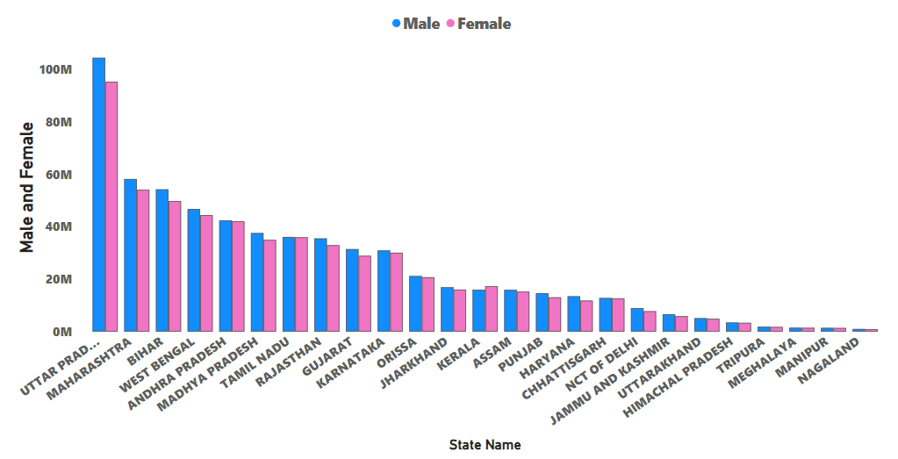

**Fig 4. Distribution between Male and Female in India**

1. **Variation in Gender Ratio**: Figure 6. Examine the gender ratio, or the proportion of men to women in a given population. Knowing how gender ratios vary from state to state can be useful in locating imbalanced areas and may also be a sign of social, cultural, or economic issues.
2. **Age-related Gender Ratios**: Look at gender distributions within particular age ranges. Gender differences in the ratios of children, working-age adults, and the elderly can reveal information about past patterns, access to healthcare, and cultural preferences.
3. **Economic Factors**: Examine how gender distribution and economic factors are related. There may be differences in male and female labor force participation rates and career choices in states with a wide range of economic activity.
4. **Long-term Trends**: Analyze long-term trends to spot changes in the distribution of gender over time. Comprehending past trends aids in putting the current demographic reality into perspective and can guide future forecasting

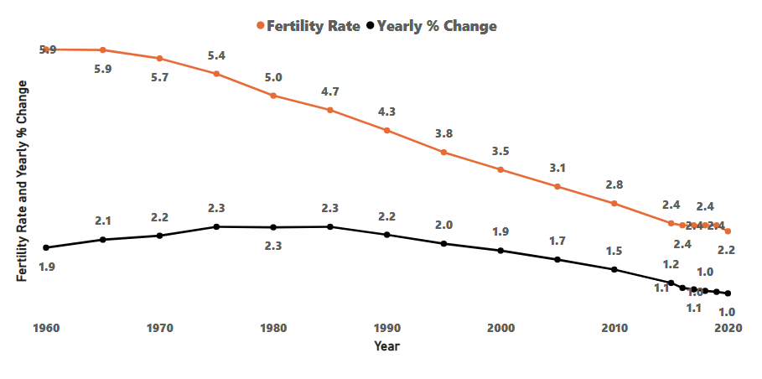

**Fig. 5. Fertility Rate and Yearly change in Population in India**

1. **Definition:** A woman’s fertility rate is the mean number of children she will give birth to in her lifetime. It is an essential demographic indicator that sheds light on patterns of population expansion.
2. **Replacement Level Fertility:** This is the fertility rate at which, in the absence of migration, a population precisely replaces itself from one generation to the next. Usually, 2.1 children are born to each woman as shown in Fig 5.
3. **Factors Affecting Fertility:** A number of factors, including as government regulations, socioeconomic status, education, access to healthcare, and cultural norms, can affect fertility rates [16]. Fig 5., represents reduced fertility rates are frequently associated with better access to family planning and higher educational attainment.
4. **Demographic Transition:** A crucial element of the model that depicts the historical change from high birth and death rates to reduced birth and death rates as a civilization experiences social and economic progress is fertility rates.

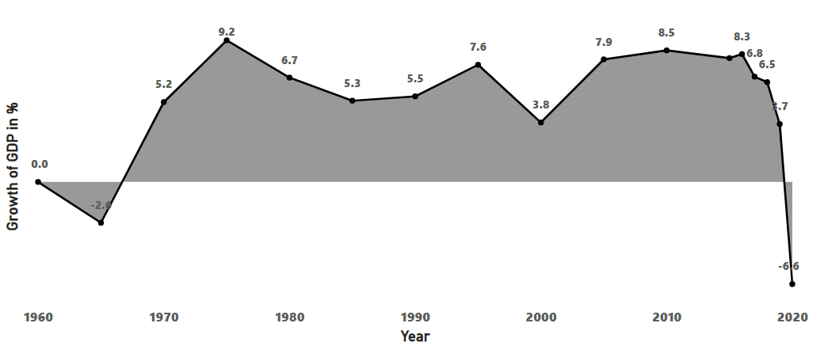

**Fig.6 Variations in Population in India**

1. **Calculation:** To get the annual percentage change in population, one compares the population at the beginning and end of the same year. The change is then expressed as a percentage of the initial population.
2. **Population Decline and Growth:** Fig 6., represents a decrease in population is shown by a negative percentage change, whereas population growth is indicated by a positive percentage change. A population that is stable is indicated by a zero percent change.
3. **Compound Growth:** Fig 6., provides a continuous indicator of growth or decline, the annual percentage change in the population is frequently compounded. Over time, compound growth may cause population changes that are exponential.
4. **Population Momentum:** Because a sizable section of the population is young and approaching reproductive age, population momentum can sustain growth even in the event that fertility rates decrease. Comprehending fertility rates and annual percentage shifts in population in fig 8., is crucial for making well-informed decisions in domains including economic development, urban planning, and public health. These demographic indicators are crucial in determining how populations will develop in the future throughout the world.

# B. Urbanization and Migration

1) **Urbanization Dynamics:** Figure 7. India’s fast urbanization offers many economic opportunities, but it also presents difficulties due to the country’s underdeveloped infrastructure. The necessity for sustainable urban planning which includes resource distribution, housing, and transportation becomes evident. In order to make sure that urbanization stimulates economic growth and increases productivity and creativity, transformative policies are needed.

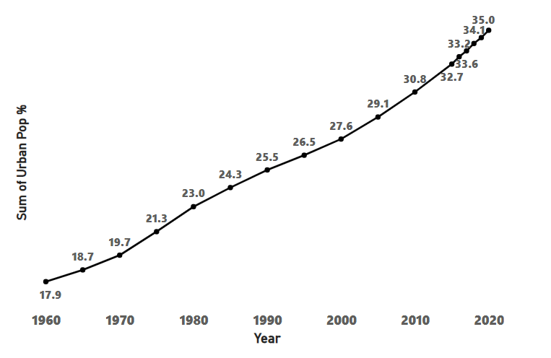

**Fig 7. Growth in Urban Population in India**

1. **Overall Urbanization Rate:** To begin, show the annual overall urbanization rate, which shows the proportion of the population living in urban regions.
2. **Yearly Trends:** Fig 9., Showcases whether the urban population is steadily growing, stabilizing, or exhibiting oscillations by presenting the annual trends in urbanization rates.
3. **Migration from Rural to Urban Areas:** Fig 7., Examine how migration contributes to the expansion of urban areas. Examine the years that saw sizable numbers of people from rural areas move into cities, and note how this affected the rate of urbanization overall.
4. **Economic Indicators:** Establish links between the rate of urbanization and economic metrics like GDP expansion. Examine the potential effects of economic booms and busts on the rate of urbanization.
5. **Changes in Population Density:** Fig 7., Examine how urban regions’ population density has changed throughout time. Determine the years that had a notable increase or concentration of population in urban areas.
6. **Urbanization and Quality of Life:** Evaluate the correlation between the expansion of urban areas and enhancements in quality-of-life metrics, like employment prospects, healthcare accessibility, and educational chances.

1. **Migration Patterns:** Figure 8. The demographic landscape is greatly influenced by patterns of migration, both domestically and internationally, which affects workforce dynamics. Nevertheless, there is a need to better integrate immigrants into the workforce and make appropriate use of their skills[5, 7]. Policies ought to be designed with the goal of easing immigrants’ transitions while identifying and maximizing their potential contributions. By closing this disparity, India will be able to take advantage of a wide range of talents and foster an inclusive culture that will optimize the financial gains from migration.

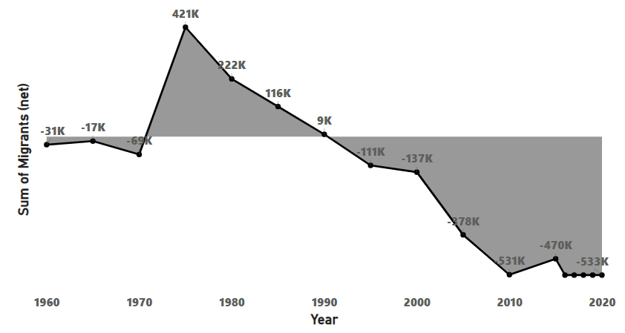

**Fig 8. Variations in Migration in India**

1. **Overall Migration Trends:** Fig. 8, Examines the trends in migration across time to pinpoint times of notable increase or decrease. Check to see if migration has been steadily rising, falling, or fluctuating over time.
2. **Reasons for Migration:** Fig 8., Examines the main causes of migration, including job possibilities, educational chances, changes in lifestyle, and escaping war. Determine how the main causes of migration have changed over the course of several years.
3. **Regional Variations**: Fig 8., Analyses the variations in migration between states and regions. Determine which areas are sources or destinations of net migration. Determine if there are any persistent migratory trends in a certain area or if there are any regional patterns.
4. **Urbanization Impact:** Evaluate how migration is affecting the trends in urbanization. Fig 10., Examines the role that migration plays in the long-term rise in the population of cities. Analyze the relationship between migration quantities and urbanization rates.
5. **Economic Repercussions:** Examine the financial effects of migration, including how it affects labor markets, industries, and local economies. Determine which industries draw immigrants and support economic expansion.

C. **Gross Domestic Product and Economic Factor -** Figure 9. While GDP is a good indicator of the state of the economy, there is still a lack of knowledge on the complex ways that demographic shifts affect economic performance. To grasp the complex linkages between GDP and demography on a qualitative level, policies and actions need to go beyond quantitative assessments [5]. This entails appreciating the qualitative aspects of how demographics affect market dynamics, consumption trends, and economic activity One of the most

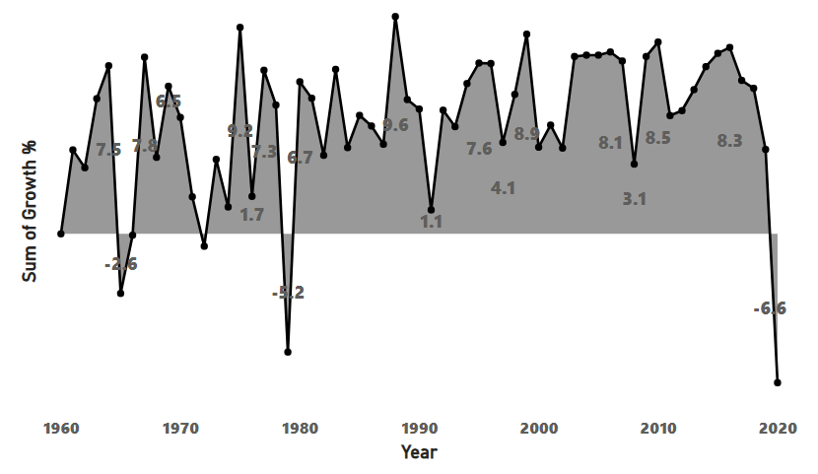

**Fig 9. Growth of GDP in India**

important ways to assess the state and direction of a country’s economy is to look at the GDP growth percentage by year. Fig 9., measures offer insightful information on the general well-being and Vigor of an economy over particular time periods. Growth percentage, which is determined as the GDP change as a percentage from year to year, indicates the rate of economic expansion or contraction. Economic decline is indicated by negative growth percentages, Fig 9., Analyzing trends, recognizing economic cycles, and evaluating the success of economic programs are all made possible by looking at this data across a number of years. Examining the relationship between growth percentages and changes in migration patterns, urbanization, and population dynamics in the context of demographic changes offers a comprehensive knowledge of the interaction between demographic determinants and economic consequences [7].

Analyzing this data over time can help predict future economic trajectories, highlight periods of increased growth or slowdowns, and uncover trends. The dynamic interaction between the people living in urban areas and GDP growth illustrates how urbanization has a transformative effect on economic development [5,6,7]. Growing urban populations can have a significant impact on a number of economic variables, either assisting or impeding GDP growth.

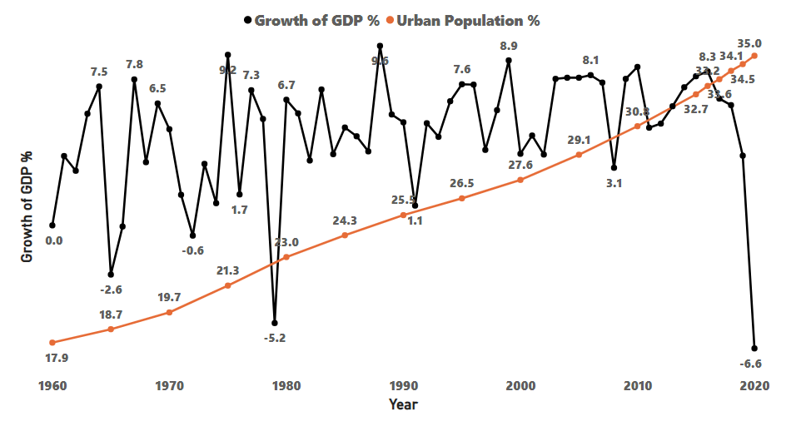

Fig 10. Relationship between urban population and growth of GDP

1. **Urbanization as an Economic Driver:** An increase in economic activity frequently accompanies an increase in the people living in urban areas. Urban regions are centers of business, industry, and services, which promotes innovation and increased productivity.
2. **GDP Growth and Infrastructure Investment:** Annual variations in the population of urban areas can be linked to equivalent expenditures on urban infrastructure. Infrastructure development, such as utilities and transportation networks, may be required as a result of increased urbanization. This can spur economic growth.
3. **Labor Market Dynamics**: - A more dynamic labor market is created by the diversified and skilled workforce that urban locations draw. An increasing number of people living in cities might result in more work possibilities and more effective labor allocation, which will boost GDP growth.
4. **Innovation and the Knowledge Economy**: The concentration of knowledge-intensive sectors and innovation clusters is frequently linked to urbanization. A knowledge-based economy that drives technical developments and contributes to overall economic growth may be fostered by the growing urban population [5].
5. **Productivity and Quality of Life:** Raising living standards, healthcare, and education levels in metropolitan areas can all lead to a healthier and more productive populace, which will boost GDP growth. An examination of the relationship between GDP growth and urban population increase on an annual basis requires a multifaceted approach that takes into account social, economic, and environmental aspects. For policymakers and scholars looking to develop policies that capitalize on urbanization’s potential benefits for equitable and sustained economic growth, this investigation is crucial.

Analyzing demographic changes in India can provide valuable insights into the country's growth trajectory. Let's break down the components of the table below provided in Fig 11.:

* 1. **Year**: This is the timeframe over which the demographic changes are being observed. Analyzing data over multiple years allows for the identification of trends and patterns.

* 1. **Population:** This represents the total number of people living in India. Population growth is a key indicator of a country's development and can impact various aspects such as employment, resource utilization, and infrastructure requirements.

* 1. **Urban Population**: This indicates the number of people living in urban areas within India. The growth of the urban population reflects urbanization trends, which can have implications for infrastructure development, housing, and service provision.

* 1. **Urban Population %:** This is the percentage of the total population residing in urban areas. It provides insight into the pace of urbanization relative to overall population growth.

* 1. **Migrants (net):** This refers to the net migration rate, which is the difference between the number of immigrants entering India and the number of emigrants leaving it. Positive net migration indicates more people are moving into the country than leaving, while negative net migration indicates the opposite.

* 1. **GDP in (billions) $:** Gross Domestic Product (GDP) measures the total economic output of a country. It is often used as an indicator of economic health and growth. Expressing GDP in billions of dollars allows for comparisons across different time periods and with other countries.

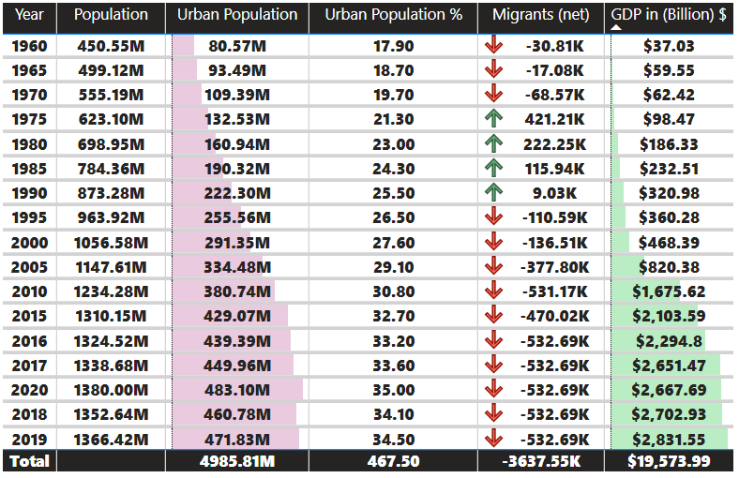

Fig 11. Analysis of Growth in India

* + Population Growth: Understanding population growth trends can help predict future resource needs and plan infrastructure development.

* + Urbanization: Rapid urbanization can pose challenges such as strain on resources and infrastructure, but it can also indicate economic opportunities in urban centers.

* + Net Migration: Positive net migration can contribute to workforce diversity and economic growth, while negative net migration may signal issues such as brain drain or economic instability.

* + GDP Growth: A growing GDP suggests economic expansion and increased prosperity, but it's essential to consider whether this growth is inclusive and sustainable.

1. **Population Distribution Shift**: Examine how the urban population percentage is changing over time relative to the total population. Are more people migrating from rural to urban areas, contributing to urbanization? Understanding this shift is crucial for urban planning, infrastructure development, and addressing the needs of growing urban populations.
2. **Impact of Migration on Urbanization:** Analyze the relationship between net migration and urban population growth. Urban areas experiencing higher rates of migration compared to rural areas. This impact the socioeconomic landscape of cities, including employment opportunities, housing demand, and cultural diversity
3. **Regional Disparities:** Explore whether demographic changes are uniform across different regions of India or if there are disparities. Some regions might experience faster urbanization and population growth due to economic opportunities, while others may lag behind. Understanding regional variations can inform targeted policies and investments to promote balanced development.
4. **Economic Growth and Urbanization**: Assess the correlation between GDP growth and urbanization. Urban areas driving economic growth, or there is a more balanced distribution of economic activity between urban and rural areas Understanding the economic dynamics of urbanization can help identify opportunities for inclusive growth and poverty reduction.
5. **Infrastructure and Service Provision:** Examine the implications of demographic changes for infrastructure and service provision. Addressing infrastructure gaps is critical for ensuring the well-being and productivity of urban residents.
6. **Sustainability and Environmental Impact:** Consider the environmental consequences of demographic changes, particularly urbanization. Are cities experiencing increased pollution, congestion, and resource depletion? Promoting sustainable urban development practices, such as green infrastructure and renewable energy adoption, is essential for mitigating environmental degradation and ensuring long-term resilience
7. **Social Cohesion and Inclusion:** Evaluate the social implications of demographic changes, including migration and urbanization, on social cohesion and inclusion. Are marginalized groups, such as rural migrants and slum dwellers, facing barriers to accessing essential services and opportunities? Promoting social inclusion and addressing disparities is crucial for building resilient and equitable communities.

# CONCLUSION

To sum up, I have analysed the complex relationships between demographic changes and the Indian economy and explored how urbanization, migration, and population dynamics contribute to economic growth. I have shown the critical trends in demography and their association with Gross Domestic Product to demonstrate that demographic changes have a profound impact on the economy of India. Urbanization seemed one of the most influential processes in terms of economic growth as it stimulates productivity growth with the development of infrastructure and new employment institutions. At the same time, urbanization leads to urban poverty and congestion, and the government should address such phenomena to ensure sustainable urban development. Similarly, migration policies have a significant impact on economic growth, as the movement of people from rural to urban areas affects labor markets, infrastructure, and social welfare systems Meeting the needs of large numbers of migrants , ensuring inclusivity and demographic participation are essential to promote economic equity development Ability to align demographic policies with economic objectives in order to achieve demographics the dividend yield emphasizes its importance. Strategic investment in education, health and skills development is essential to grow human capital and to harness the demographic dividend to stimulate innovation, employment and productivity. In conclusion, the findings highlight the urgent need to integrate demographic considerations into policy making in economic policy. By recognizing the interplay between demographics and the economy, policymakers can develop targeted interventions to overcome the potential of demographic change for sustainable economic growth and it covers everyone in India.

**8. References:**

1. Neha Jain and Srinivas Goli, “Demographic Change and Economic Growth in India”, in Munich Personal RePEc Archive, 1st ed. New Delhi, 2021, pp. 2 – 6.
2. Jain N., Goli S.,” Demographics Change and Economic Growth in India”, in Social Science Research Network, New Delhi, 2021, pp. 6-16.
3. Yamini Jindal, “Quantifying Demographic Dividend in India and its Impact on Economic Growth: A State-Level Study”, in Arthshastra Indian Journal of Economics Research, New Delhi, 2020, pp. 2-7.
4. Aiyar, S., Mody, A. (2011). The demographic dividend: evidence from the Indian States, IMF Working Paper, no. 11/38. New York, International Monetary Fund.
5. Curtis CC, Lugauer S, Mark NC (2017) Demographics and aggregate household saving in Japan, China, and India. J Macroecon 51:175–191
6. Mason A, Lee R, Jiang JX (2016) Demographic dividends, human capital, and saving. J Econ Ageing 7:106–122
7. An, C.-B., and S.-H. Jeon. 2006. “Demographic Change and Economic Growth: An Inverted-U Shape relationship.” *Economics Letters* [92 (3)](https://doi.org/10.1016/j.econlet.2006.03.030): 447–454,
8. Hu Q, Lei X, Zhao B (2020) Demographic changes and economic growth: impact and mechanisms. China Econ J.
9. Bloom, D. E., and D. Canning. 2004. “Global Demographic Change: Dimensions and Economic Significance.” NBER Working Paper No. 10817. Cambridge, MA: National Bureau of Economic Research.
10. Bloom, D. E., D. Canning, and G. Fink. 2010. “Implications of Population Ageing for Economic Growth.” *Oxford Review of Economic Policy* [26 (4)](https://doi.org/10.1093/oxrep/grq038): 583–612.
11. Lindh, T., and B. Malmberg. 1999. “Age Structure Effects and Growth in the OECD, 1950– 1990.” *Journal of Population Economics* [12 (3)](https://doi.org/10.1007/s001480050107): 431–449.
12. Loayza, N., K. Schmidt-Hebbel, and L. Serven. 2000. “What Drives Private Saving across the World?” *Review of Economics and Statistics* [82 (2)](https://doi.org/10.1162/003465300558678): 165–181.
13. Maestas, N., K. J. Mullen, and D. Powell. 2016. “The Effect of Population Aging on Economic Growth, the Labor Force and Productivity.” NBER Working Paper No. 22452. Cambridge, MA: National Bureau of Economic Research.
14. Noda, H. 2011. “Population Aging and Creative Destruction.” *Journal of Economic Research* 16: 29–58.
15. Zhang, J., and J. S. Zhang. 2005. “The Effect of Life Expectancy on Fertility, Saving, Schooling and Economic Growth: Theory and Evidence.” *Scandinavian Journal of Economics* [107 (1)](https://doi.org/10.1111/j.1467-9442.2005.00394.x): 45– 66.
16. Acemoglu, D., and S. Johnson. 2007. “Disease and Development: The Effect of Life Expectancy on Economic Growth.” *Journal of Political Economy* [115 (6)](https://doi.org/10.1086/529000): 925–985.
17. Acemoglu, D., and P. Restrepo. 2017. “Secular Stagnation? The Effect of Aging on Economic Growth in the Age of Automation.” *American Economic Review* [107 (5)](https://doi.org/10.1257/aer.p20171101): 174–179.